Author: Anish Mahapatra  
Shallow Neural Networks

Superscripts will be used to denote the later. [1] would indicate layer 1, [2] would indicate layer 2 and so on.  
Superscripts with () brackets are used to indicate training examples.

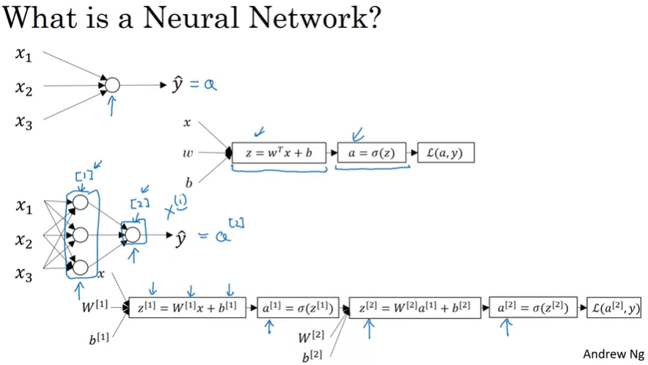

For logistic regression, we had the z followed by a calculation. In this neural network, we jut do it multiple times, as a z followed by a calculation, and a z followed by a calculation and then we finally compute the loss in the end.

**Neural Network Representation**

Input Layer -> [Hidden layer] -> Output Layer  
a -> activations (values that different layers are passing on to the neural network.

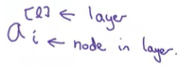

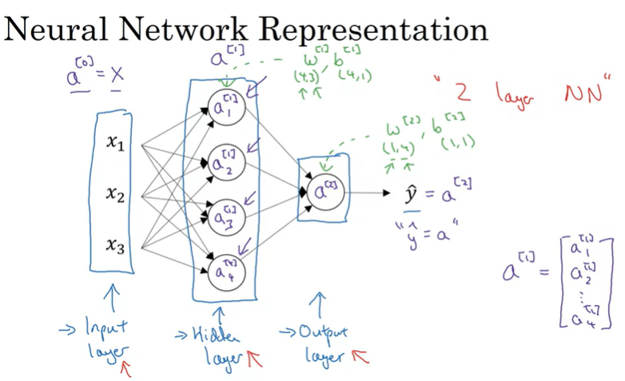

Number of layers in a neural network: INPUT Layer is not counted. So the above would be a 2 – Layer – Neural network.  
Layers 0, 1, 2 -> 2 Layer NN

w[2] (input), b[2] (output)

w[2] dimension is (1,4) because the hidden layer has 4 hidden units and the output layer has just one hidden unit

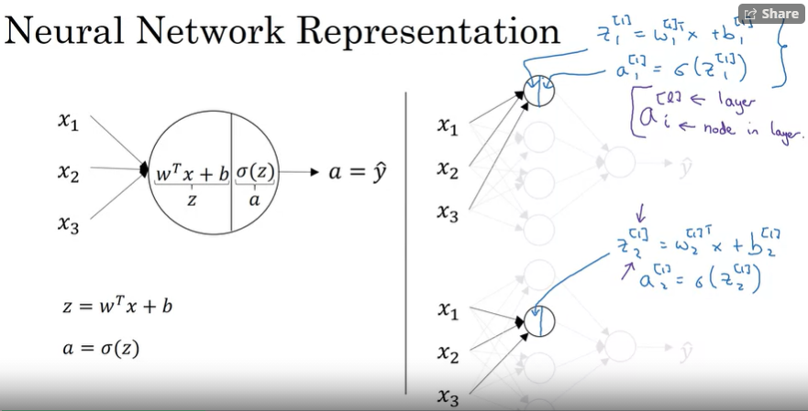

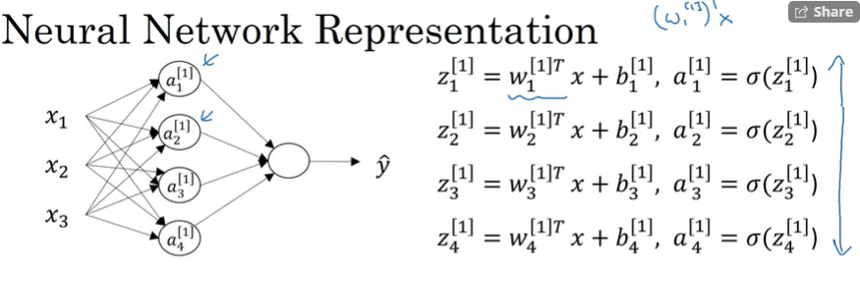

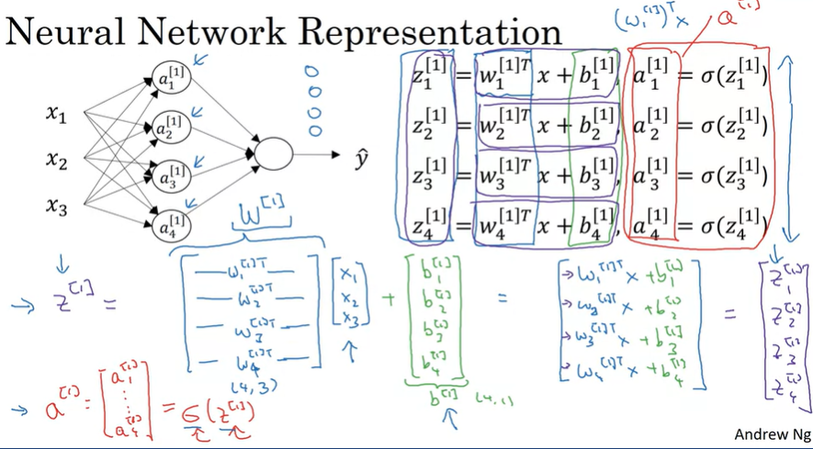

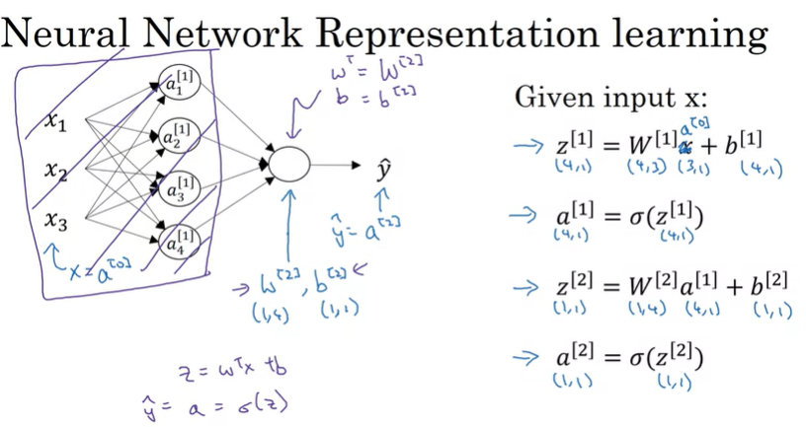

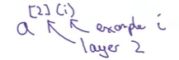

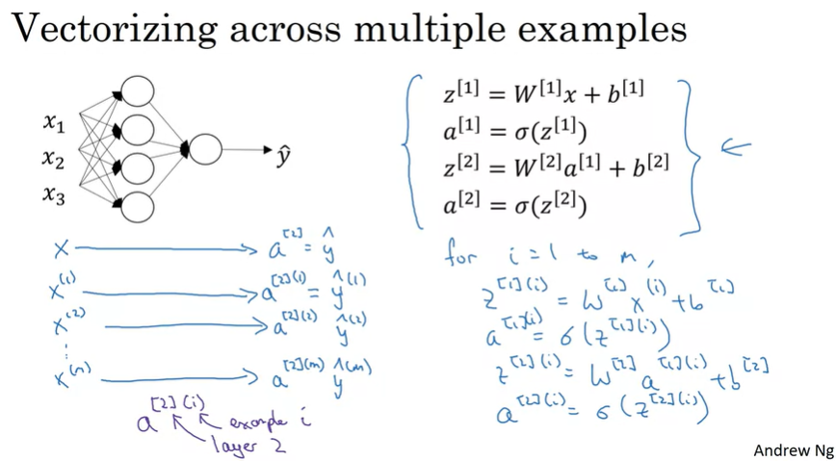

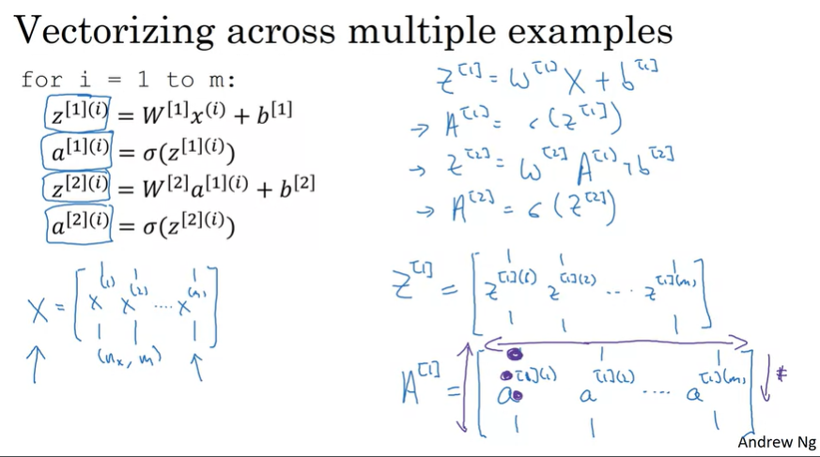

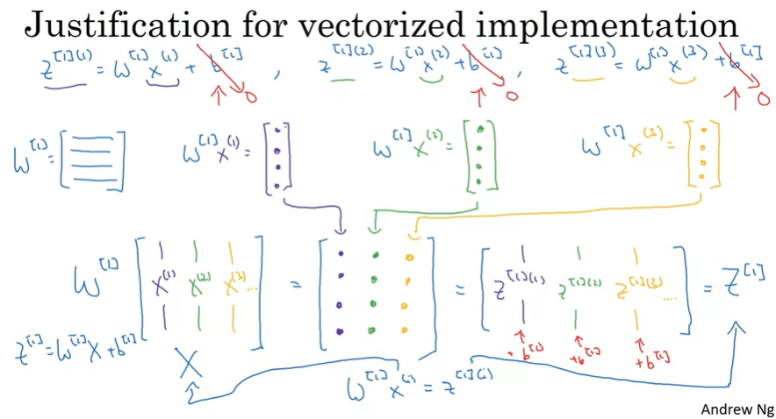

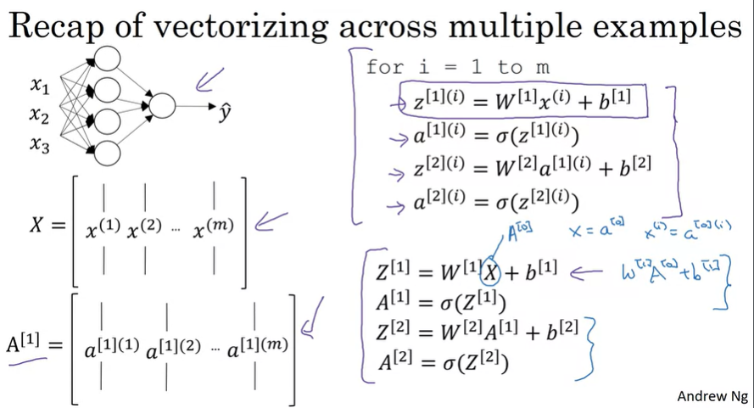

Activation Functions:



The sigmoid activation function can be used for binary classification (almost never use this)

The ReLU (Rectified Linear Unit) is the most popular activation function

Tan h can also be used and has a higher preference than the sigmoid function as it centers itself at 0

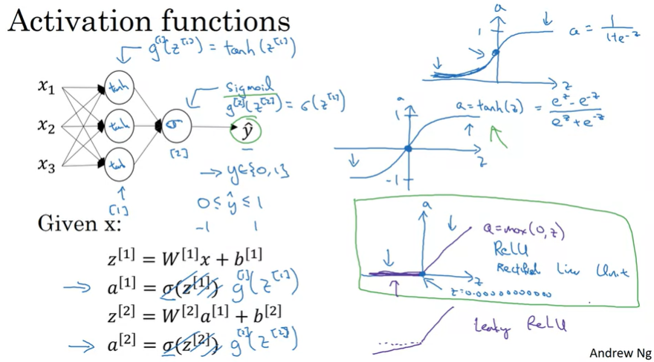

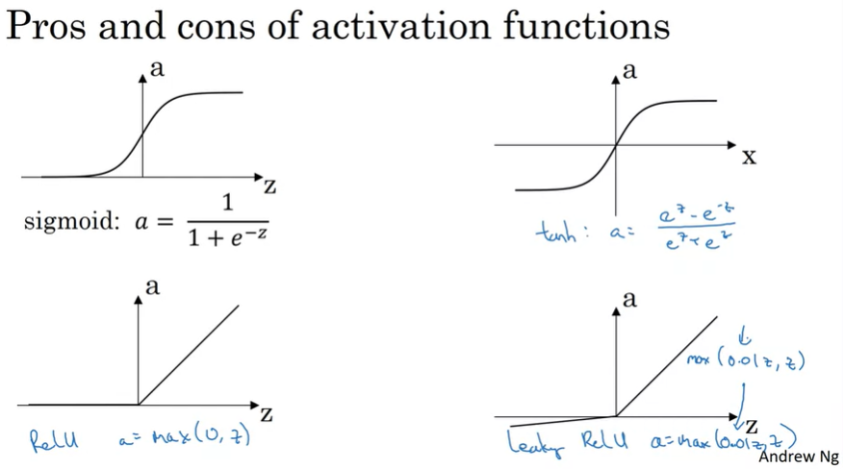

**Why do we need to use a** **non-linear activation function?**

The composition of two or more linear functions is itself a linear function, which is not as useful for deep learning.

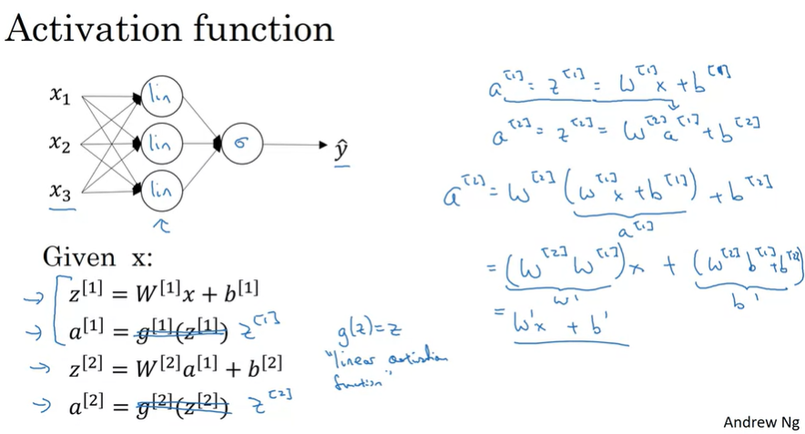

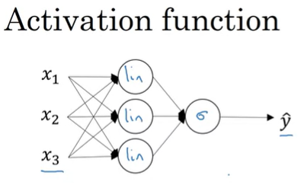

The one place where you might want to use a linear function: if you are doing machine learning on a regression problem  
(usually in the input layer)

Derivatives of activation function

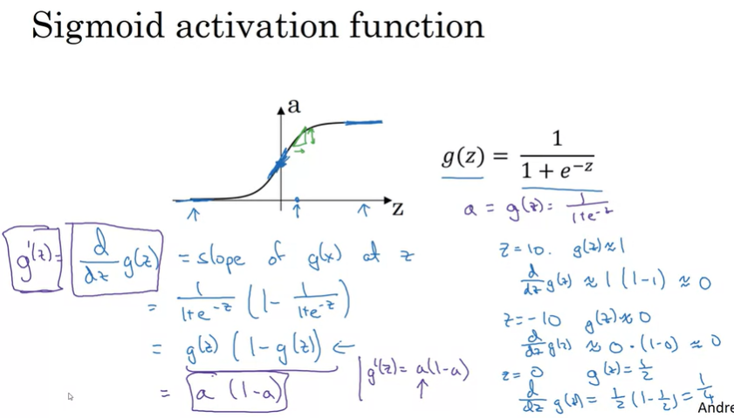

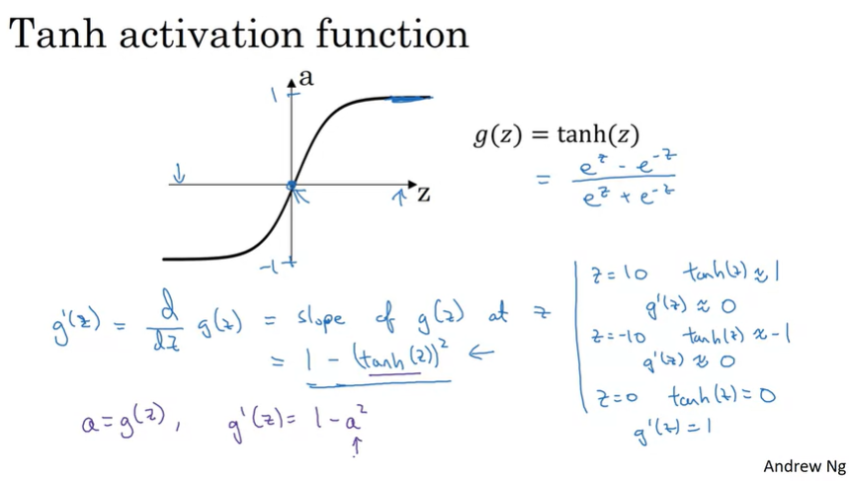

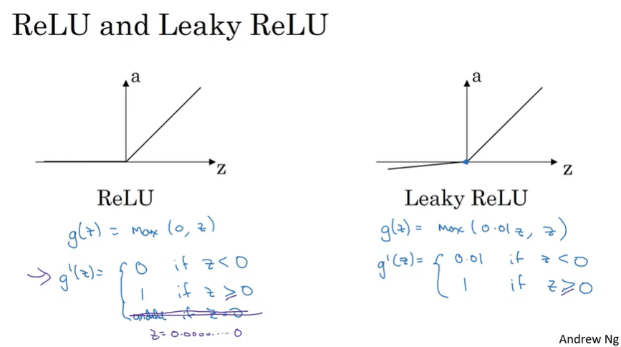

**Gradient Descent for Neural Networks**

Equations to get back propagation working!

